1. 
2. We will teach you how to use Apache Kafka to build **Spring Boot Event Driven Microservices.**
3. **Instructor:**
4. This course will teach you everything from the beginning about Kafka
   1. How to download Kafka.
   2. How to make it work on your system.
5. 
   1. This course is very hands-on and practical because we will create and configure microservices from the very beginning.

What is that we will learn in this course?

1. How to use Apache Kafka to build Spring Boot Event-Driven Microservices.
2. Instructor: I will use Google Slides to explain Microservices and Apache Kafka Architecture.  
   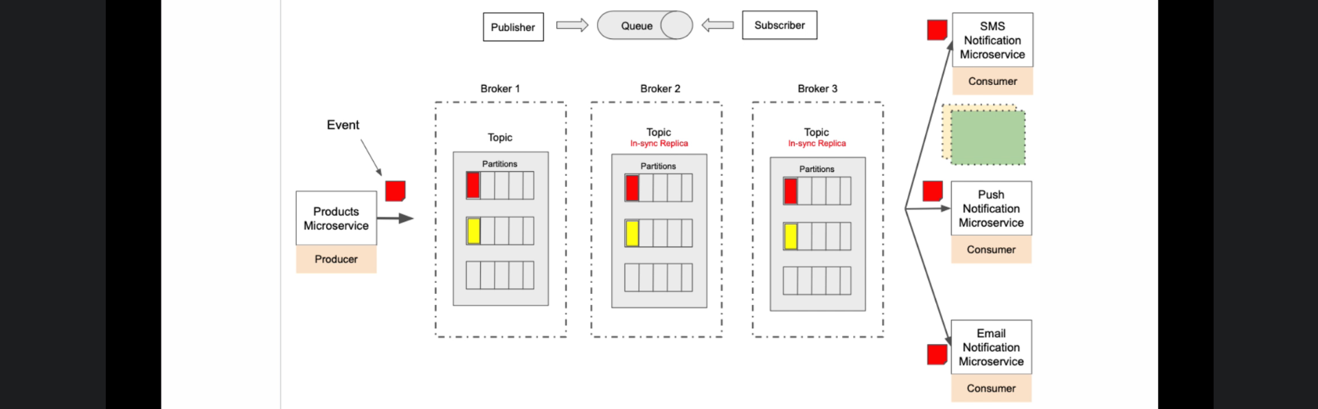

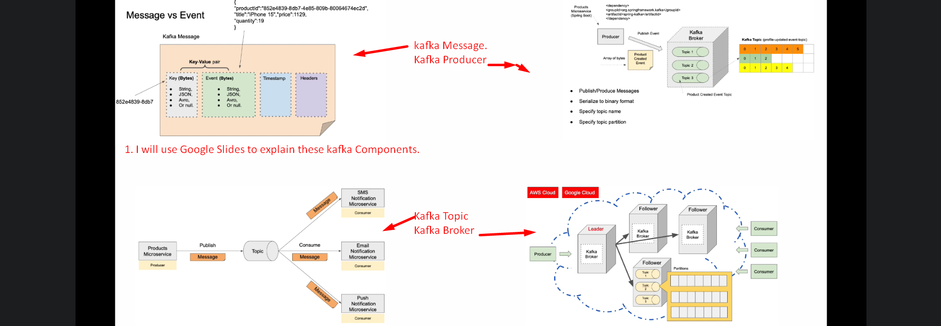

1. We will see how to download and run multiple Kafka Brokers (Services) in a cluster.
2. We will use command line interface
   1. To create a topic.
   2. To send/read a message to and from a kafka topic.
3. 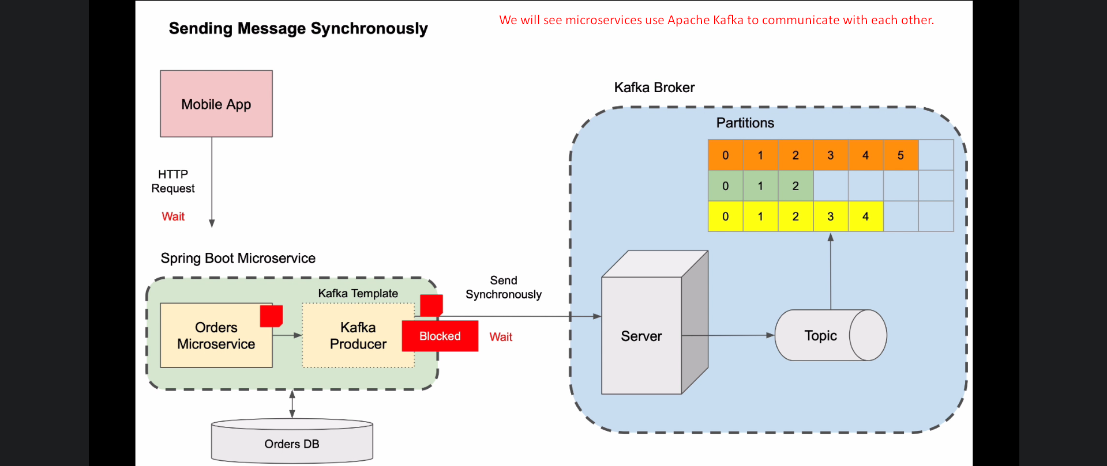
4. How to scale microservices so that they can produce data faster.
5. How to recover from an error and how to make it more fault-tolerant.
6. And much more.
7. With this course you will have good knowledge and skills about to confidently build Event-Driven Microservices that work with Apache Kafka.